**Knee Segmentation Report**

1. Read dcm file format

info = dicominfo('OA_30.dcm');

Y = dicomread(info);

figure

imshow(Y,[]);

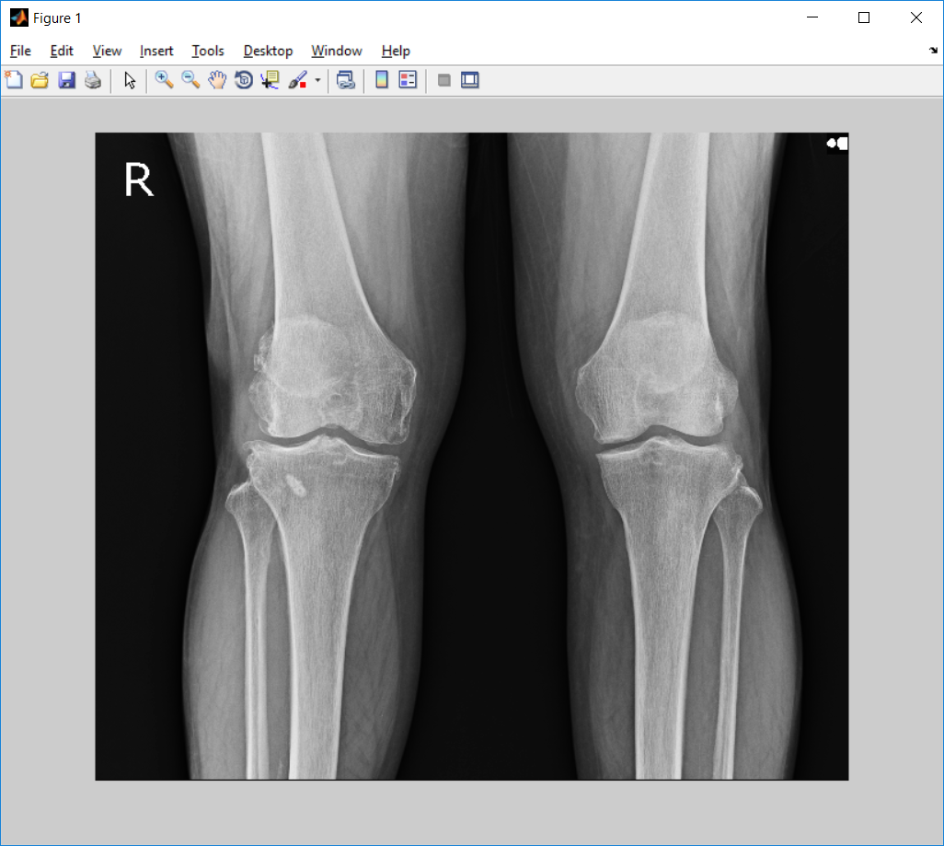

1. Contrast image

>> J = imadjust(Y);

>> imshow(J,[]);

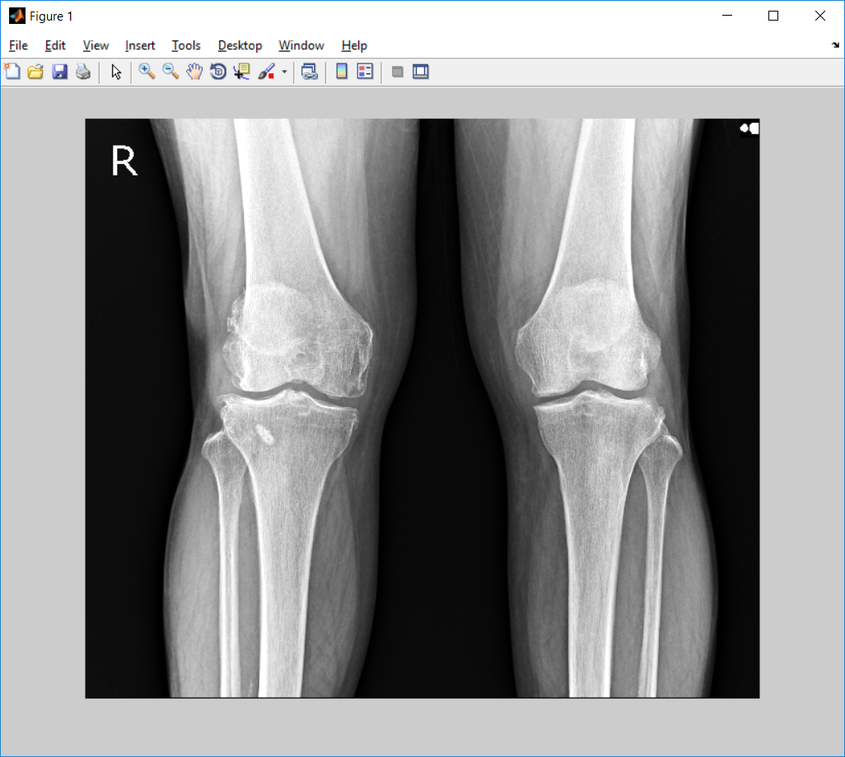

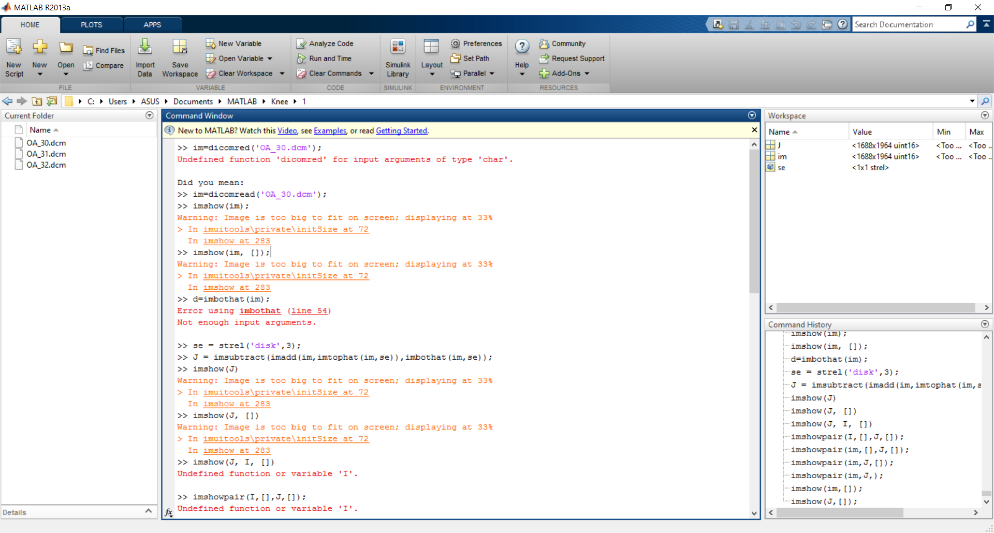

>> I=dicomread('OA_30.dcm');

>> J = histeq(I);

>> J1 = histeq(J);

>> J2 = histeq(J1);

>> imshow(J2,[]);

Sobel on the crop.jp2

q=imread(‘crop.jp2’);

[~, threshold] = edge(q, 'sobel');

fudgeFactor = .99;

BWs = edge(q,'sobel', threshold * fudgeFactor);

figure, imshow(BWs), title('binary gradient mask');

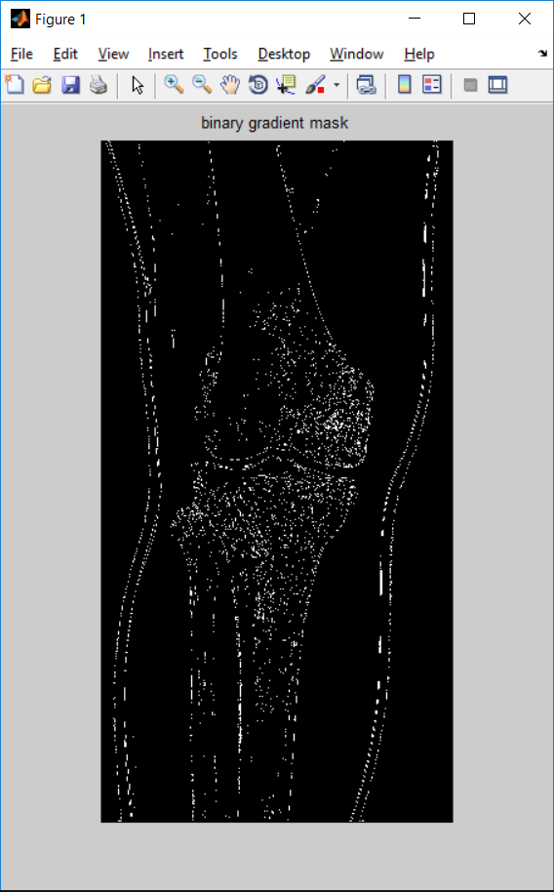

Dilate the image

se90 = strel('line', 3, 90);

se0 = strel('line', 3, 0);

BWsdil = imdilate(BWs, [se90 se0]);

figure, imshow(BWsdil), title('dilated gradient mask');

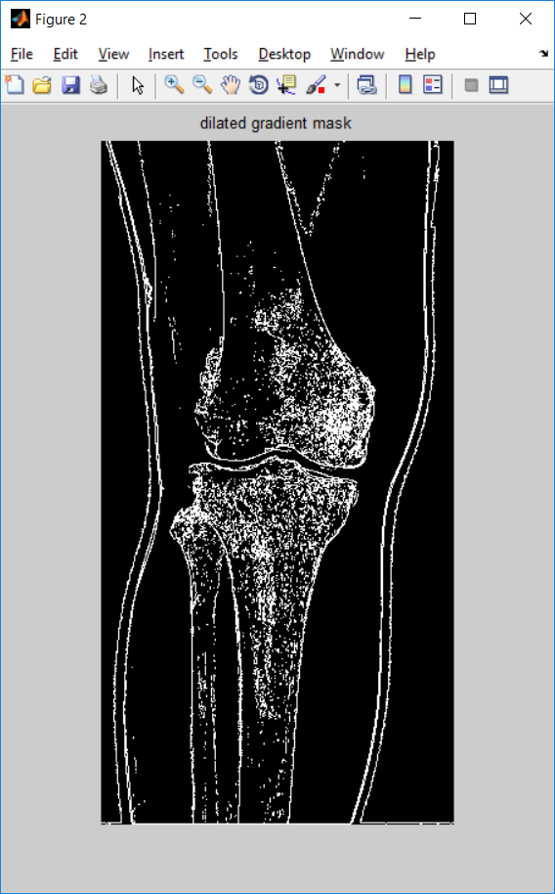

Fill the image

BWdfill = imfill(BWsdil, 'holes');

figure, imshow(BWdfill);

title('binary image with filled holes');

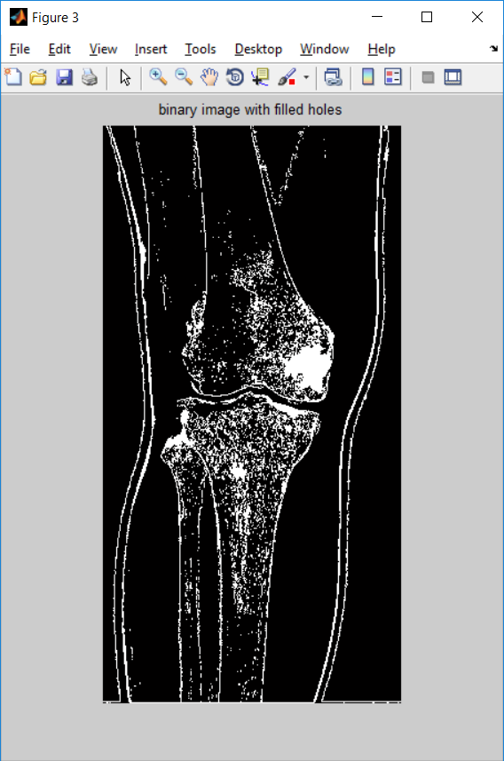

Clear the bother of image

BWnobord = imclearborder(BWdfill, 4);

figure, imshow(BWnobord), title('cleared border image');

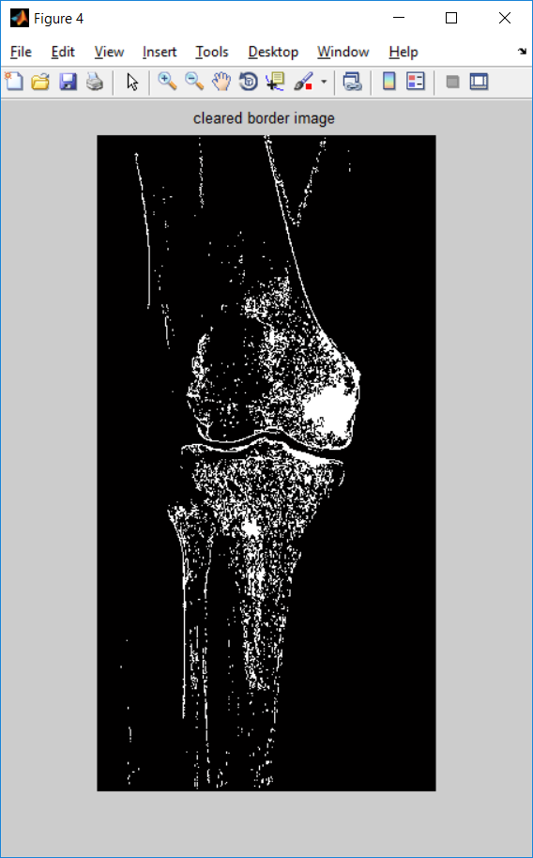

<https://www.mathworks.com/help/images/examples/detecting-a-cell-using-image-segmentation.html>

Noise remove

MN=imread('kneesegment.jpg');

mnr=rgb2gray(MN);

K = wiener2(mnr,[15 15]);

>> imshowpair(MN,K,'montage');

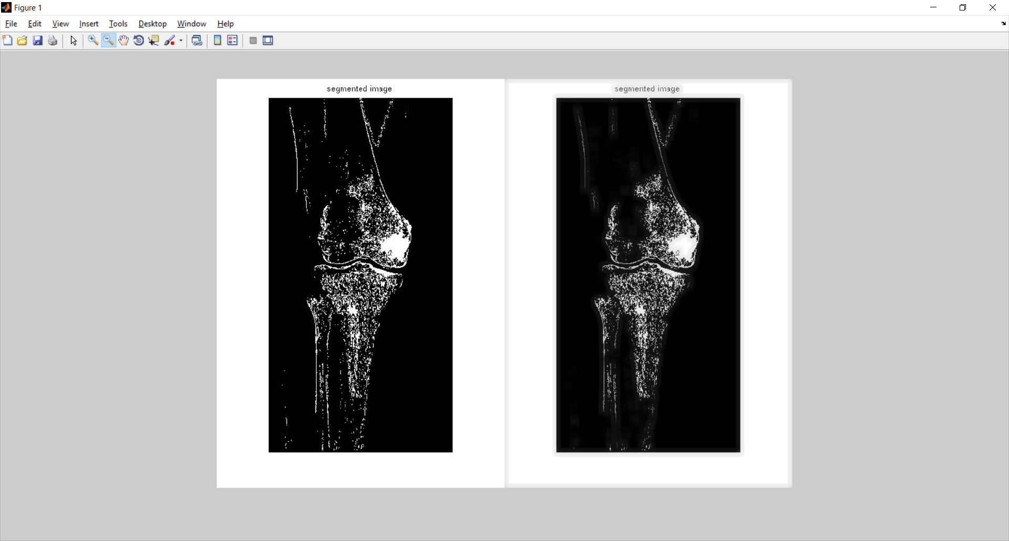

Threshold function

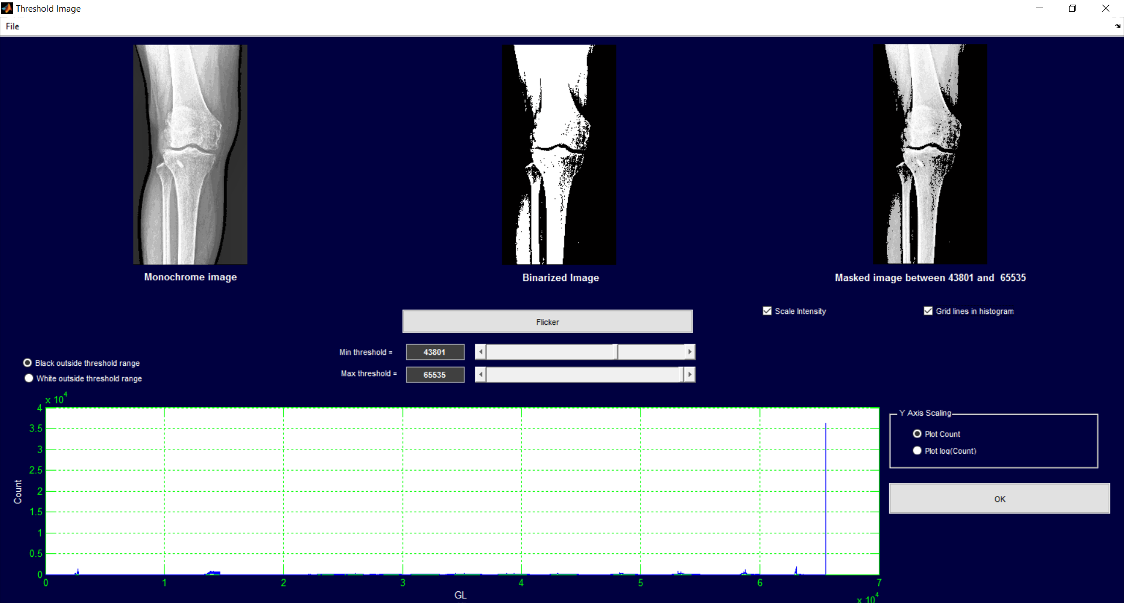

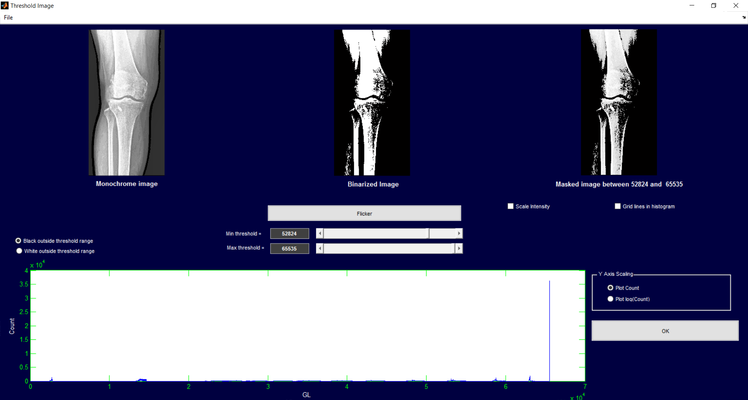

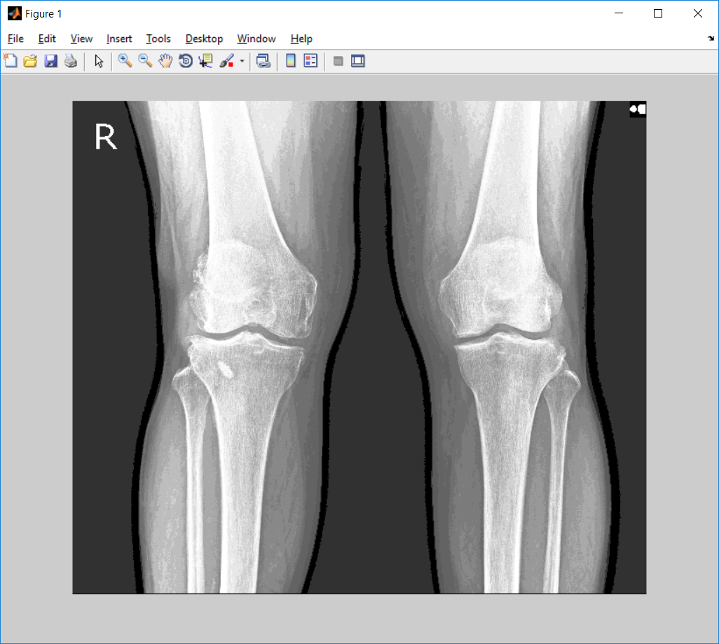

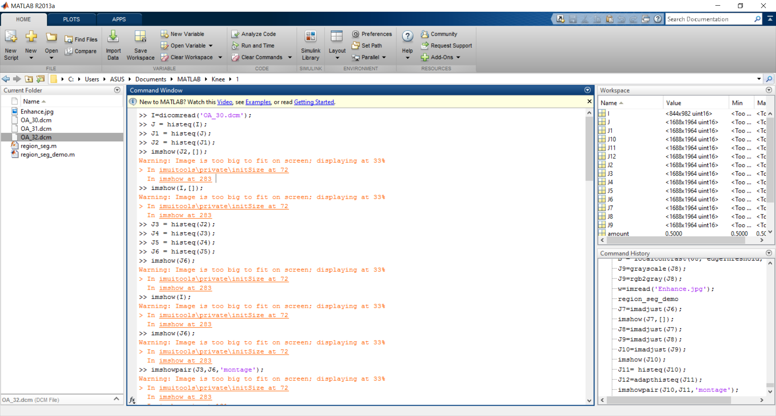

q1=dicomread('OA_12.dcm');

w=histeq(q1);

w1=histeq(w);

w2=imsubtract(w1,200);

====================================

I=dicomread('OA_30.dcm');

J = histeq(I);

J1 = histeq(J);

J2 = histeq(J1);

J3 = histeq(J2);

J4 = histeq(J3);

J5 = histeq(J4);

J6 = histeq(J5);

J7 = imaaadddjust(J6);

J8 = imaaadddjust(J7);

J9 = imaaadddjust(J10);

J11 = histeq (J10);

J12=adapthisteq(J11);

imshowpair(J1,J12,'montage');

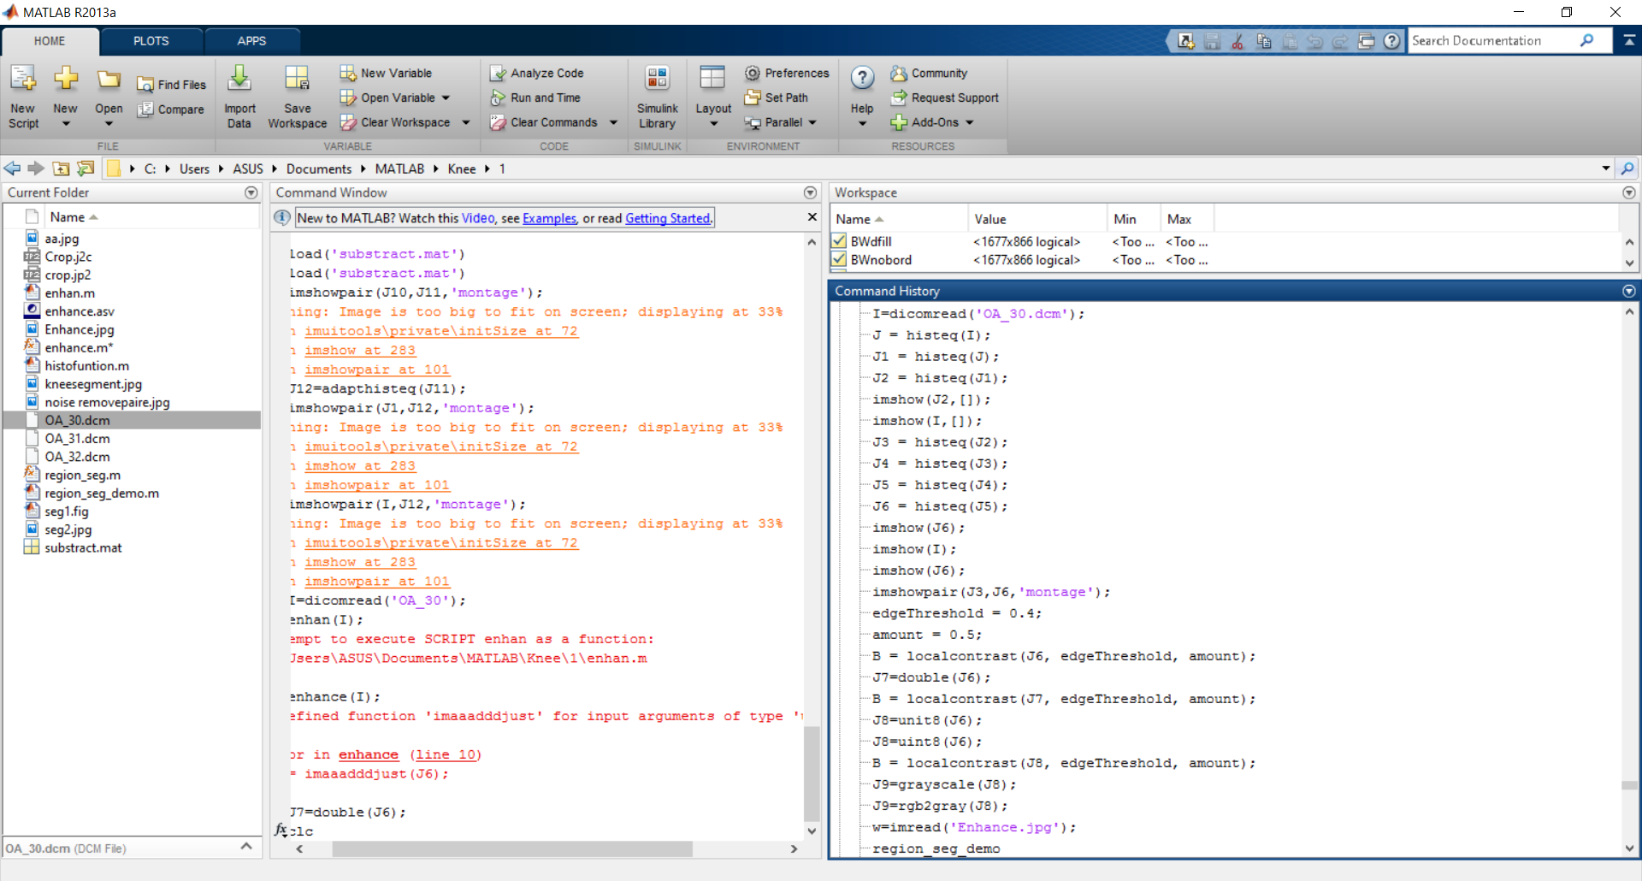

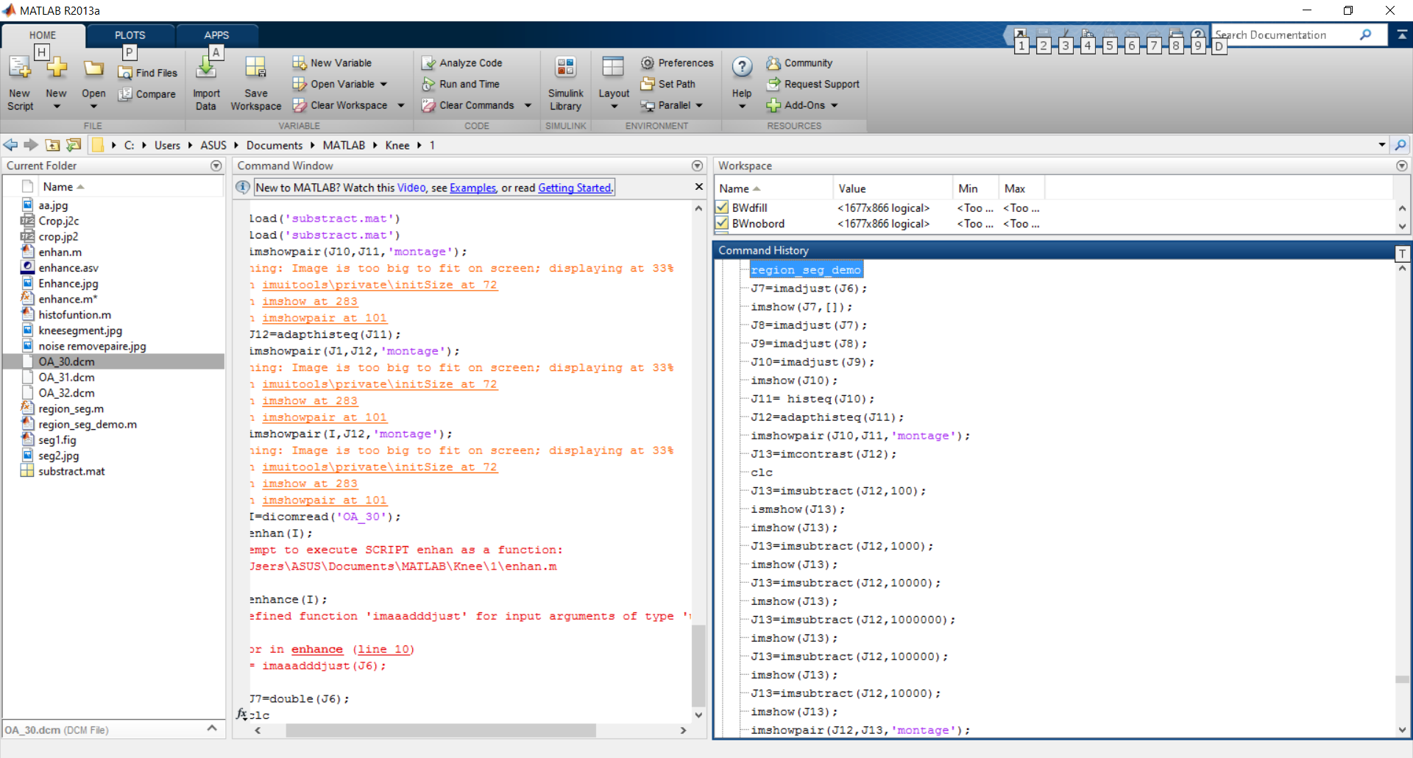

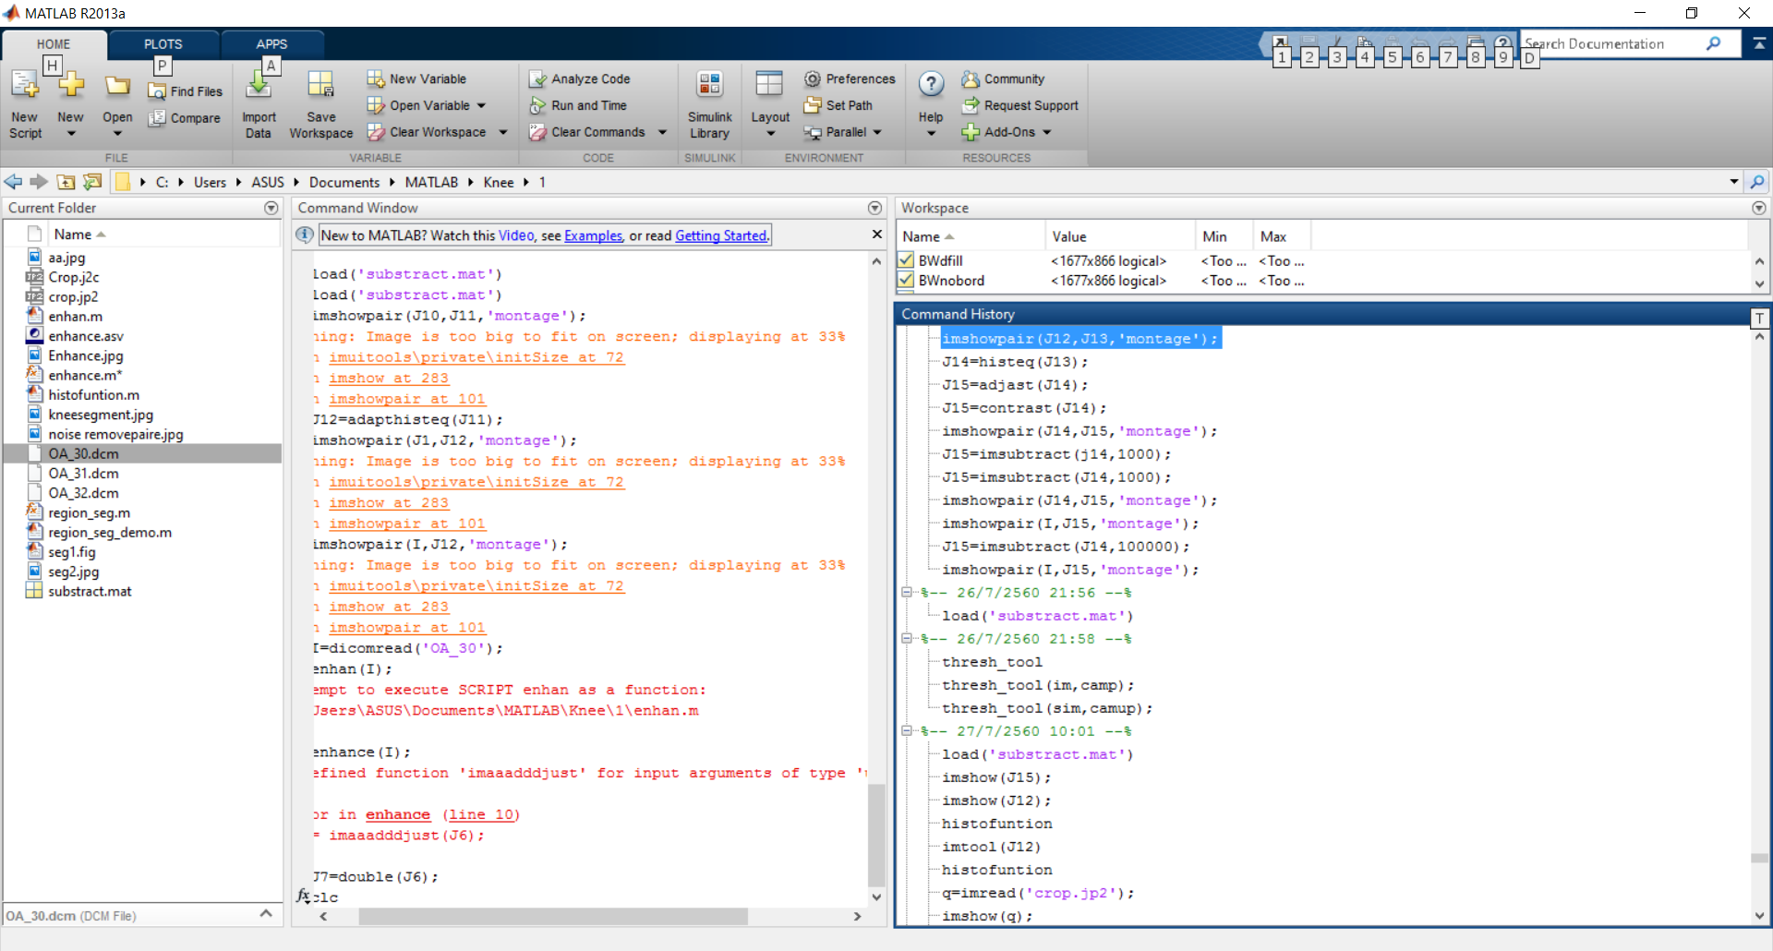

OA_20.dcm

>> u=dicomread('OA_20.dcm');

>> z=histeq(u);

>> z1=histeq(z);

>> z2=histeq(z1);

>> z3=histeq(z2);

>> z4=histeq(z3);

>> z5=histeq(z4);

>> z6=histeq(z5);

>> z7=imadjust(z6);

>> z8=imadjust(z7);

>> z9=imadjust(z8);

>> z10=imadjust(z9);

>> z11=histeq(z10);

>> z12=adapthisteq(z11);

>> imshow(z12);

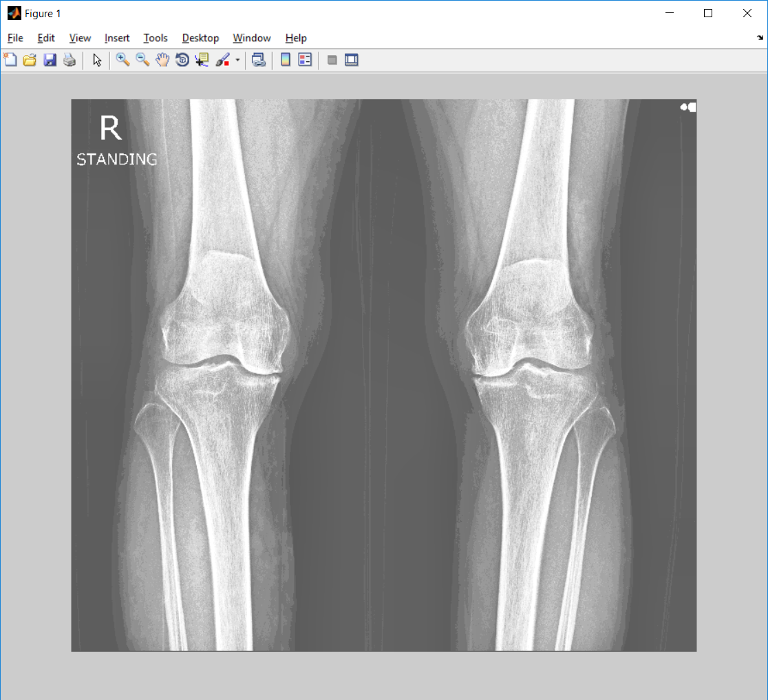

>> v=imread('crop_OA_20.jp2');

>> [~, threshold] = edge(v, 'sobel');

>> fudgeFactor = .90;

>> BWs = edge(v,'sobel', threshold * fudgeFactor);

>> figure, imshow(BWs), title('binary gradient mask');

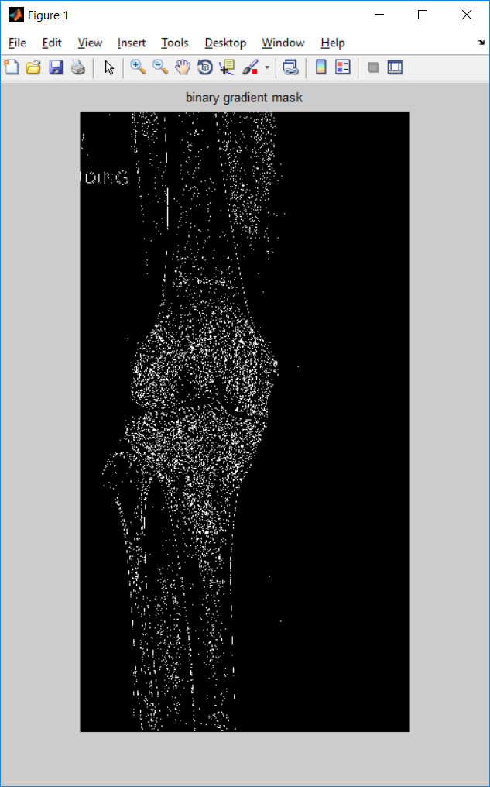

se90 = strel('line', 3, 60);

se0 = strel('line', 3, 0);

BWsdil = imdilate(BWs, [se90 se0]);

figure, imshow(BWsdil), title('dilated gradient mask');

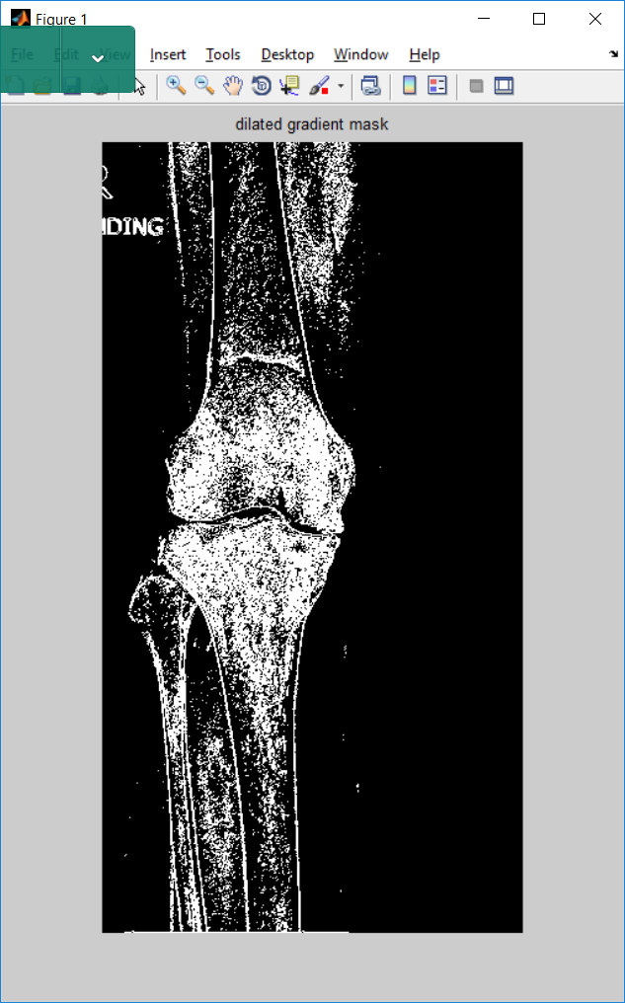

OA_12.dcm

>> u=dicomread('OA_12.dcm');

>> z=histeq(u);

>> z1=histeq(z);

>> z2=histeq(z1);

>> z3=histeq(z2);

>> z4=histeq(z3);

>> z5=histeq(z4);

>> z6=histeq(z5);

>> z7=imadjust(z6);

>> z8=imadjust(z7);

>> z9=imadjust(z8);

>> z10=imadjust(z9);

>> z11=histeq(z10);

>> z12=adapthisteq(z11);

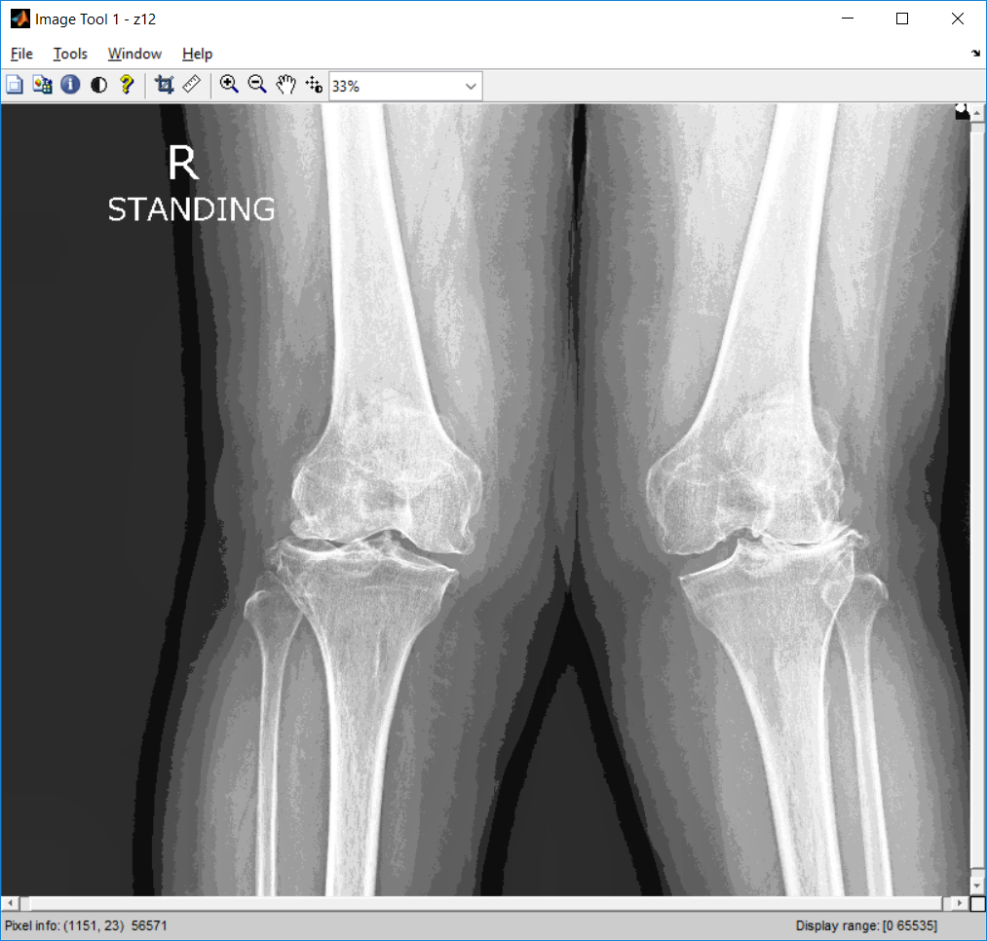

v=imread('crop_OA_12_v3.jp2');

[~, threshold] = edge(v, 'sobel');

fudgeFactor = .99;

BWs = edge(v,'sobel', threshold * fudgeFactor);

figure, imshow(BWs), title('binary gradient mask');

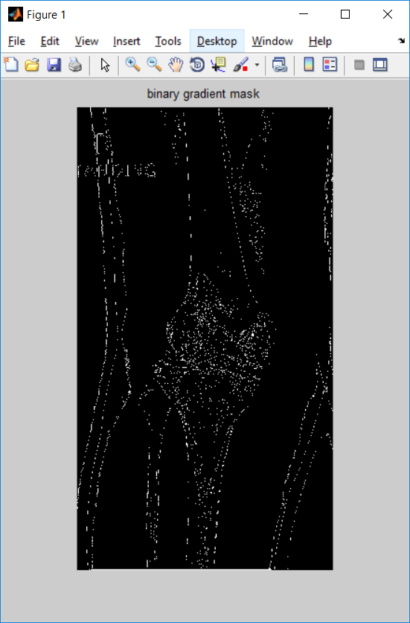

se90 = strel('line', 3, 90);

se0 = strel('line', 3, 0);

BWsdil = imdilate(BWs, [se90 se0]);

>> figure, imshow(BWsdil), title('dilated gradient mask');

